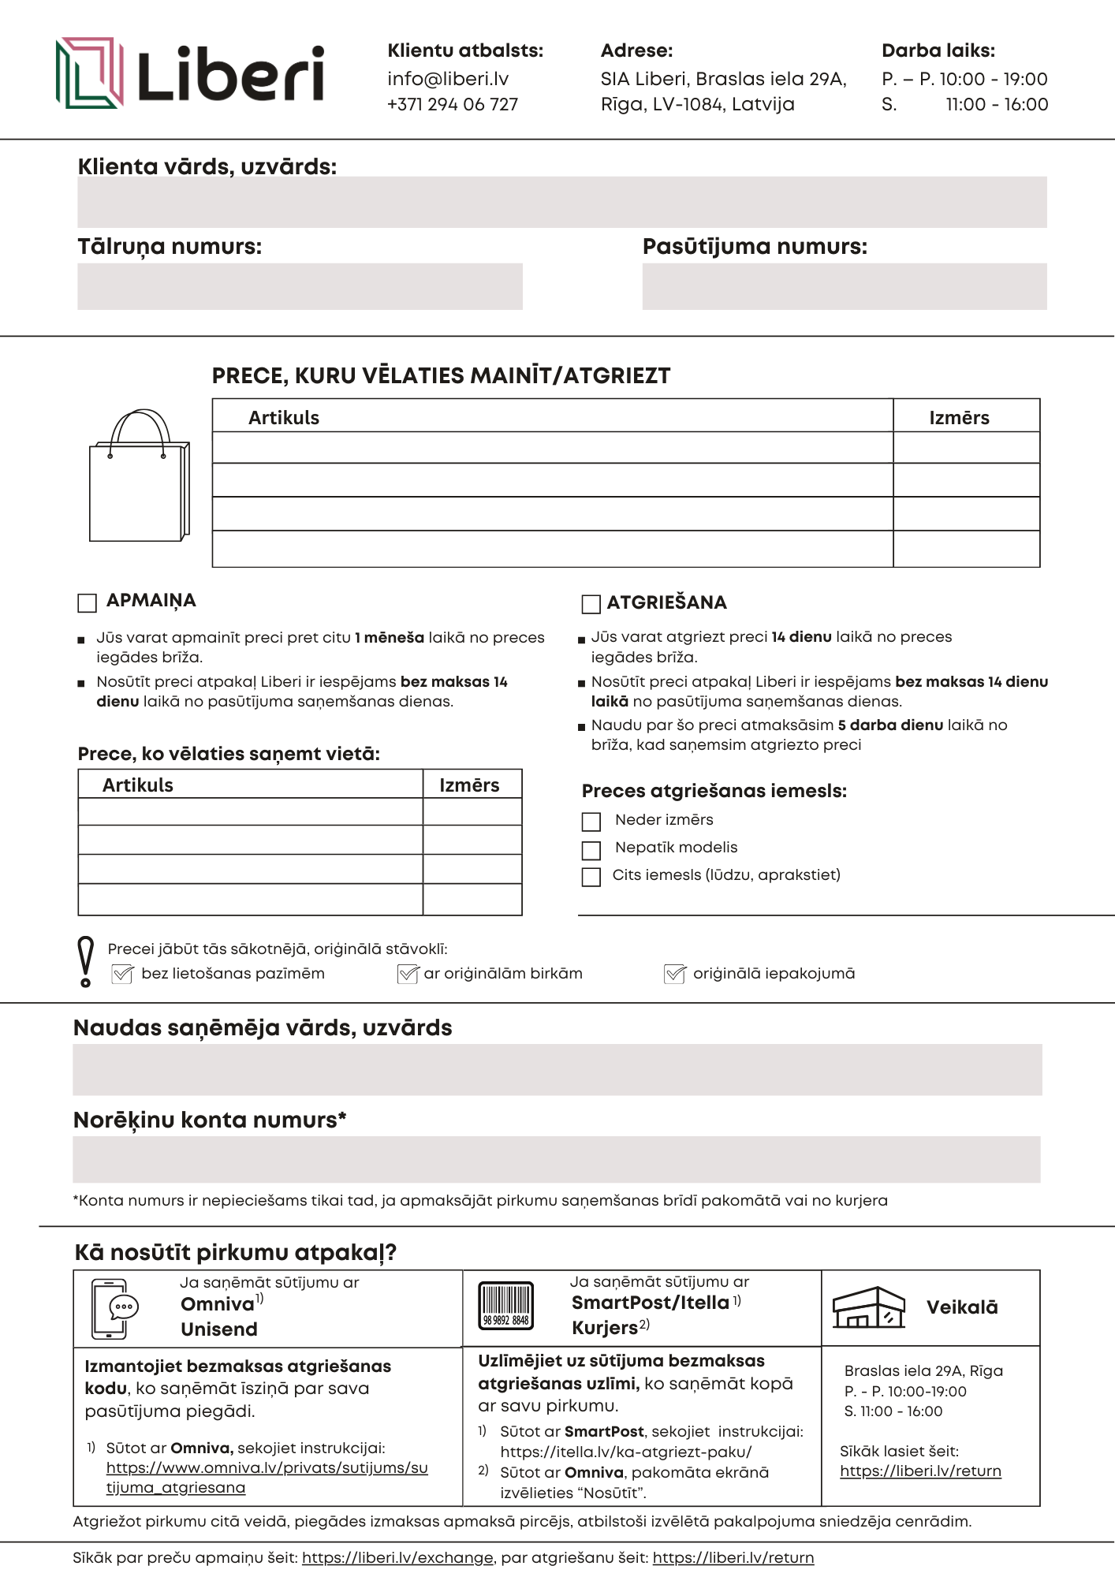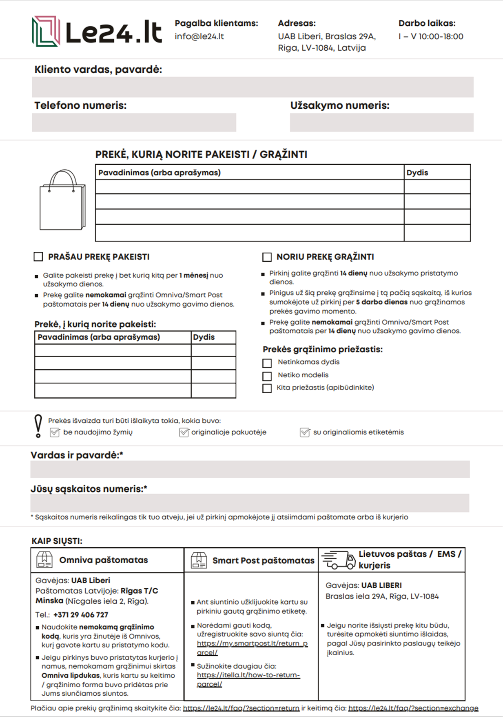

<https://liberi.lv/return>

<https://www.omniva.lv/privats/sutijums/sutijuma_atgriesana>

https://itella.lv/ka-atgriezt-paku/

<https://liberi.lv/exchange>